# Data Centric RAD

## Lab 9 JSF Introduction

### Part 1 JSF Student Details Form with ManagedBean

* Update Lab 8 Part 2 to have a ManagedBean called *Student* with the following properties:
  + **private** String firstName;
  + **private** String surname;
  + **private** String address;
  + **private** String phone;
  + **private** **int** age;
  + **private** String sex;
  + **private** **int** yearBorn;

Any of these properties entered on the form should be stored in the ManagedBean and any properties displayed should be read from the ManagedBean.

The *Male* radio button should be the default button selected when the form appears.

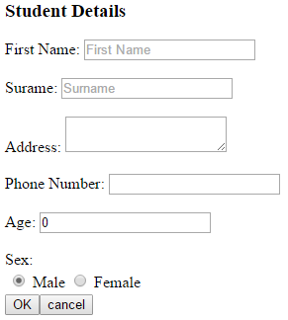

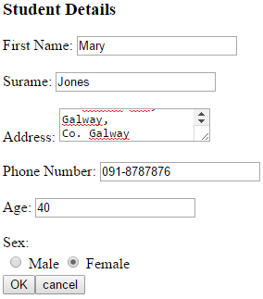

When the user presses OK his/her details should be displayed as follows.

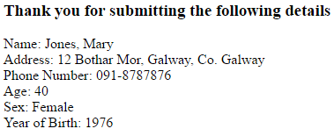

### Part 2 JSF Student Details Form with Drop Down Menu and ManagedBean

* Update Part 1 to include two drop down menus one of which should allow the user to choose his/her country:

|  |  |
| --- | --- |
| Value used in Code | Value Displayed to User |
| IRL | Ireland |
| UK | United Kingdom |
| FRA | France |
| GER | Germany |
| SPA | Spain |
| USA | United States of America |
| OTH | Other… |

The other should allow the user to choose his/her course:

|  |  |
| --- | --- |
| Value used in Code | Value Displayed to User |
| BSC | B.Sc. in Computing and Software Development |
| BSCHONS | B.Sc. (Hons) in Computing and Software Development |

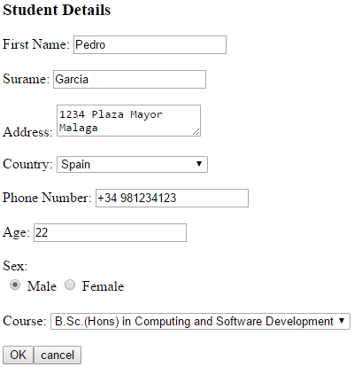

When the user presses *OK* the full country name and the Expected Year of Graduation should be displayed.

(If a user chose the course “B.Sc. in Computing and Software Development” his/her Expected Year of Graduation should be 3 years after the current year.

If a user chose the course “B.Sc. (HONS) in Computing and Software Development” his/her Expected Year of Graduation should be 4 years after the current year.):

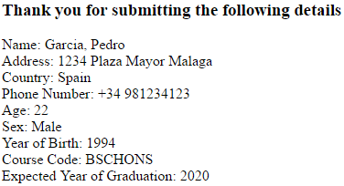

### Part 3 Request Scope

* Write a JSF web application that has a ManagedBean called Counter, which has the following variable:

private int x;

* Add a webpage called index.xhtml, which looks as follows:

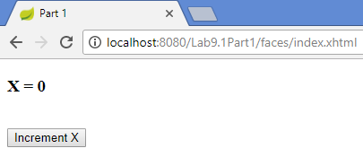

* Each time the *Increment X* button is pressed, X xhould be incremented by 1, however the ManagedBean should be RequestScoped, which means it is recreated each time a web request is made to it.

### Part 4 Session Scope

* Write a JSF web application that has a ManagedBean called ShoppingCart, which has the following variables:

private ArrayList<String> cart;

private String newItem;

* Add a webpage called index.xhtml, which looks as follows:

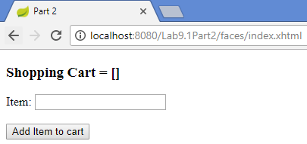

* Initially, the shopping cart has no items.
* Each time an item is added to the shopping cart the webpage is updated:

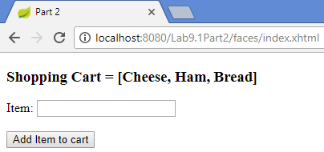

* Each browser session that is opened should have its own unique Shopping Cart:

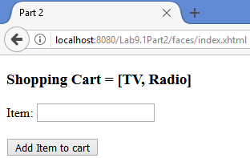

### Part 5 Application Scope

* Write a JSF web application that has a ManagedBean called Counter, which has the following variable:

private int totalClicks;

* Add a webpage called index.xhtml, which looks as follows:

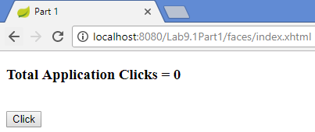

* Each time the *Click* button is pressed, totalClicks should be incremented by 1.
* This variable keeps track of the total number of times the *Click* button was pressed. *S*o even if a different user, in a different browser/session presses the *Click* button it should be added to the running total.

### Part 6 Form Error Messages

* Write a JSF web application that has a ManagedBean called Employee, which has the following properties:

**private** String id;

**private** String firstName;

**private** String surname;

**private** String address;

* The application should have a view (xhtml page) called *employee_confirm.xhtml* which looks as follows:

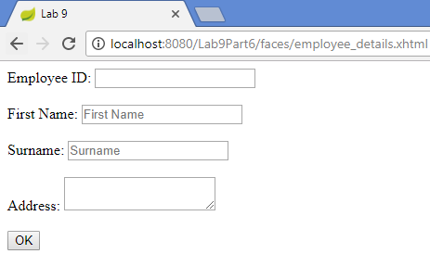

* The fields *Employee ID*, *First Name* and *Surname* are mandatory and if any of them do not have a value when the *OK* button is pressed, form error messages should be displayed:

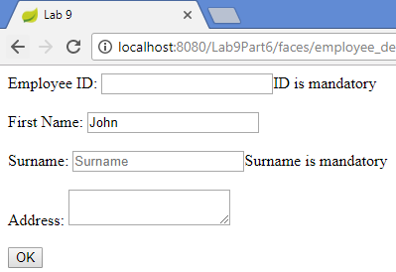

* When all required data is entered and the *OK* button pressed, a view called *employee_details.xhtml* should display the data entered as follows:

